DISCLAIMER

Please read and understand the contents of this installation and user manual.


Failure to read the manual may lead to personal injury, inferior results or damage to the

Trendonix ThreeD. Always make sure that anyone who uses the 3D printer knows and understands the contents of the manual to make the most out of the Trendonix ThreeD.

The conditions or methods used for assembling, handling, storage, use or disposal of the device are beyond our control and may be beyond our knowledge. For this and other reasons, we do not assume responsibility and expressly disclaim liability for loss, injuries, damage, or expense arising out of or in any way connected with the assembly, handling, storage, use or disposal of the product.

The information in this document was obtained from sources which we believe are reliable. However, the information is provided without any warranty, express or implied, regarding its correctness.

Intended use

Trendonix 3D printers are designed and built for fused deposition modeling for various high quality plastics like PLA, ABS, CPE within a commercial/business environment. The mixture of precision and speed makes the Trendonix 3D printers the perfect machines for concept models, functional prototypes and also the production of small series. Although we achieved a very high standard in the reproduction of 3D models with the usage of Cura, the user remains responsible to qualify and validate the application of the printed object for its intended use. While being an open filament platform the best results will be achieved with Trendonix certified filament, while effort has been made in order to match material properties with machine settings.

Copyright © 2017 Trendonix. All rights reserved worldwide.

This language version of the manual is verified by the manufacturer (Original manual).

No part of this publication, including pictures may be reproduced and/or made public, whether by printing, photocopying, microfilm or by any other means whatsoever, without the prior written permission of Trendonix.

TABLE OF CONTENTS

1. SAFETY AND COMPLIANCE 4

Safety messages 5
Hazards 6

2. INTRODUCTION 7

Trendonix ThreeD at a glance 8

Specifications 10

3. INSTALLATION 11

Installation 13

4. OPERATION 15

Visual and Audio Feedback 16
Display and controller 17

First use 29

Bed leveling 30

Loading and changing filament 31

Starting a print 32

Cura software 33

Changing nozzles 34

5. MAINTENANCE 35

The feeder 36
Atomic method 37

5. HELP & SUPPORT 38

Troubleshooting 39
Support 41
PREFACE

This is the installation and user manual for your Trendonix ThreeD. The manual contains chapters about the installation, operation and maintenance of the Trendonix ThreeD.

The manual contains important information and instructions on safety, installation and use. Please read all information and follow the instructions and guidelines in this manual carefully. This ensures that you will obtain great quality prints and that possible accidents and injuries will be prevented. Make sure that everyone who uses the Trendonix ThreeD has access to this manual.

Every effort has been made to make this manual as accurate and complete as possible. The information is believed to be correct but does not purport to be all inclusive and should be used only as a guide. Should you discover any errors or omissions, please bring this to our attention, so that we can make amendments. This will enable us to improve our documentation and service to you.

1
SAFETY AND COMPLIANCE

Safety is of the utmost importance when working with your Trendonix ThreeD. This chapter is about safety and hazards. Please read all information carefully to prevent possible accidents and injuries.

6

SAFETY MESSAGES

This manual contains warnings and safety notices.


Provides additional information that is helpful to do a task or to avoid problems.

Warns of a situation that may cause material damage or injuries if you do not follow the safety instructions.

GENERAL SAFETY INFORMATION

The Trendonix ThreeD generates high temperatures and has hot moving parts that can cause injury. Never reach inside the Trendonix ThreeD while it is in operation. Always control the Trendonix ThreeD with the button at the front or the power switch at the back. Allow the Trendonix ThreeD to cool down for 5 minutes before reaching inside.

Do not change or adjust anything on the Trendonix ThreeD unless the change is authorised by the manufacturer.

Do not store items in the Trendonix ThreeD.

The Trendonix ThreeD is not intended for use by persons (including children) with reduced physical and/or mental capabilities, or lack of experience and knowledge, unless they have been given supervision or instruction concerning the use of the appliance by a person responsible for their safety.

Children should be under constant supervision when using the Trendonix ThreeD.

Always unplug the printer before performing maintenance or modifications.

HAZARDS

ELECTROMAGNETIC COMPATIBILITY (EMC)

This equipment generates, uses, and can radiate radio frequency energy and, if not installed and used in accordance with the instruction manual, may cause harmful interference to radio communications. Operation of this equipment in a residential area is likely to cause harmful interference in which case the user will be required to correct the interference at his own expense.

ELECTRICAL SAFETY

The Trendonix ThreeD operates on 24 volts (Extra-low-voltage) and is therefore outside the scope of the low-voltage directive. The power supply meets all CE mark regulations and is protected against short-circuit, overload, overvoltage and over temperature. Only use the Trendonix ThreeD with power supplies and cables supplied by Trendonix Infotech Private Limited.

MECHANICAL SAFETY

The Trendonix ThreeD contains many moving parts, but the stepper motors do not have enough power to cause serious injuries and the moving gears have been covered. Still, it is advised to only reach in the machine when it is turned off.

RISK OF BURNS

There is a potential risk of burns, as the print head can reach temperatures of up to 260°C and the heated bed can reach temperatures of up to 120°C. The nozzle of the print head is mostly surrounded by an aluminum cover to prevent contact, but we still advise against reaching into the machine when the print head and/or heated bed are hot.

Always let the printer cool down for at least 30 minutes before performing maintenance or modifications.

HEALTH

The Trendonix ThreeD is designed to print with PLA and ABS filaments. The use of other materials is at your own risk.

When printing with ABS, small concentrations of Styrene vapor can be released. In some cases, this can cause headaches, fatigue, dizziness, confusion, drowsiness, malaise, difficulty in concentrating, and a feeling of intoxication. Therefore good ventilation is required, and long term exposure should be avoided. It is advisable to use a fume hood with active carbon filtering for ductless extraction. Fume extraction is mandatory for use in offices, classrooms, etc.

Printing with pure PLA is considered safe, although good ventilation is still advised for possible unknown vapors released from coloring dyes in colored PLA.

Only use your printer in a well-ventilated area.

2
INTRODUCTION

Meet TRENDONIX ThreeD, you own 3D printer!

TRENDONIX ThreeD AT A GLANCE
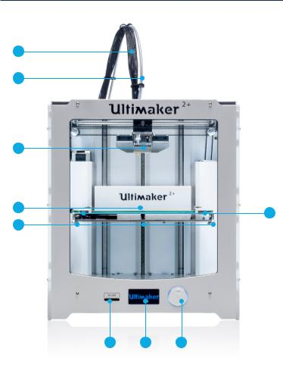

4

3

2

1
5

9

8 7 6

1 | Build plate | 4 | Print head cable | 7 | Display
2 | Print head | 5 | Build plate clamps | 8 | SD card slot
3 | Bowden tube | 6 | Push/rotate button | 9 | Build plate screws

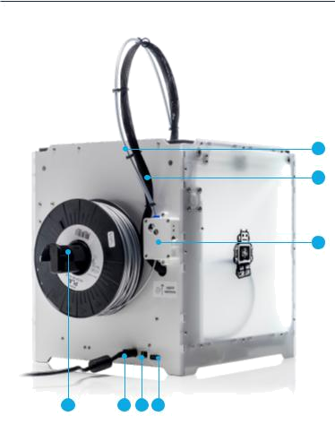

1

2

3

7 6 5 4

1 | Bowden tube | 4 | Power switch | 7 Spool holder
2 | Print head cable | 5 | USB connector
3 | Feeder | 6 | Power connector

SPECIFICATIONS

PRINTER AND PRINTING PROPERTIES

Print technology | Fused Deposition Modeling (FDM)
Print head | Swappable nozzle
Build volume | 210 x 210 x 250 mm
Filament diameter | 1.75 mm
Nozzle diameter | 0.4mm
Layer resolution | 100 micron, 200 micron, 300 micron
X, Y, Z accuracy* | 12.5, 12.5, 2.5.. micron
Print head travel speed | Upto 150 mm/s
Build plate* | Heated Aluminium build plate (20° to 100° C)
Supported materials | PLA, ABS, PETG etc.
Nozzle temperature | 180° to 250° C
Build plate temperature | 40° to 100° C
File transfer | Standalone 3D printing from SD card , Using PC
Build plate leveling | Manual, assisted leveling process

*Trendonix printers can be used with third party filament. However for the best printing results we recommend you use Trendonix PLA, ABS or CPE.

PHYSICAL DIMENSIONS

Dimensions (excluding spool holder)*

Dimensions (including spool holder)

Nett weight

Shipping weight

357 x 342 x 388 mm

493 x 342 x 588 mm

11.3 kg

18.5 kg

POWER REQUIREMENTS

Input

Output

AMBIENT CONDITIONS

Operating ambient temperature

Nonoperating temperature

SOFTWARE

Print preparation

Supported OS

Supported file types

100 - 240 V, 50 - 60 Hz

221 W max. 12 V DC, 30 A

15° to 32° C

0° to 32° C

Cura(free)

Mac OS X, Windows, Linux

STL, OBJ, DAE

3
UNPACKING AND INSTALLATION

Follow the instructions carefully while installing your TRENDONIX ThreeD.

THIS IS INCLUDED

The Trendonix ThreeD is supplied with an SD card in the 3D printer and several other accessories.

Check if all these accessories are included before continuing.
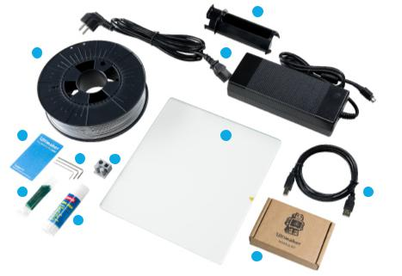

3

1 2

8 11

9 10

7 4

6

5

- 0.75 kg filament

- Power supply and cable

- Glass plate

- USB cable

- Nozzle kit

- Glue stick

- Grease

- Calibration card

- Hex wrenches (1.5 mm, 2 mm, 2.5 mm)

- Test print

- Glass plate

INSTALLATION

To install the Trendonix ThreeD:

PLACING SPOOL HOLDER

- Take the spool holder and insert the top part in the hole at the left side of the Trendonix ThreeD.

- Screw the back plate to the side of the printer to hold it in place.
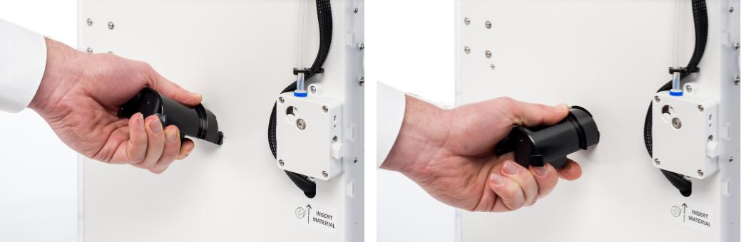

CONNECTING POWER SUPPLY

- Plug the power cable into a wall socket and connect the other side of the cable to the Trendonix ThreeD.
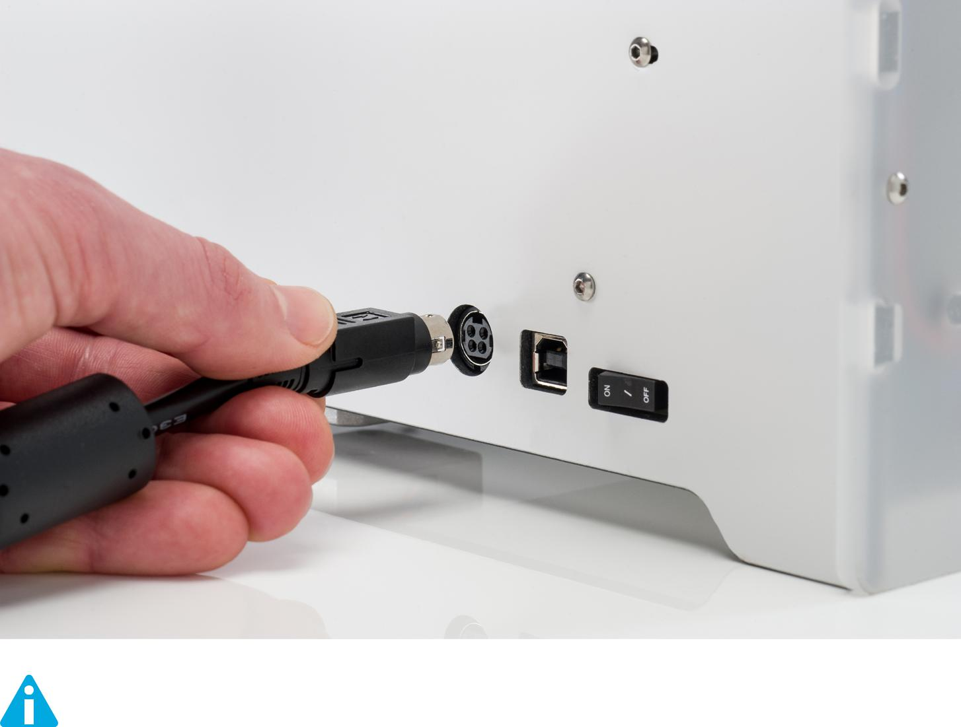

Before connecting, make sure the power switch is in the “off” position.

Only use the power supply that came with your Trendonix ThreeD.

7

4
OPERATION

Now it’s time to turn on your TRENDONIX ThreeD and start printing.

This chapter provides information about the printer status, display, first use, bed leveling, loading and changing the filament, the Cura software and changing nozzles among other things.

VISUAL AND AUDIO FEEDBACK

Your printer has RGB LEDs inside it to notify you of the printer’s state. The following table details the colors and their meaning:
S. No. | Color | Operation
1. | Red, Orange, Purple, Azure then White | When the printer is switched ON.
2. | Blue | When print command is sent to printer.
3. | Purple | When heat bed has reached target temperature.
4. | Red | When nozzle has reached target temperature.
5. | Orange* | When printing.
6. | Green | Print complete.
7. | White | When printer is idle.

The printer plays sounds to indicate certain events.
S.No. | Sound | Operation
1. | Mario tune | When the printer is switched ON.
2. | Beep | When knob is pressed.
DISPLAY AND CONTROLLER

The display at the front side of the Trendonix ThreeD shows all the necessary information for setting up and using your Trendonix ThreeD. You can navigate through menus by rotating and/or pushing the button at the right side of the display. Rotate to select or control an action; push to confirm an action. When pushing the button you will hear a “beeping” sound to confirm the action. A blinking button means the Trendonix ThreeD is waiting for user input.

When turning on your Trendonix ThreeD after the first use, you will always see the Trendonix logo first after which the main menu appears. The main menu offers three options: “Tune”, “Prepare”, ”Control”, “Pause/Resume Printing”, “Print from SD” and “About Printer”.

TUNE

The Tune menu is only available during active printing. Most items in this menu are editable values.
PREPARE
The Prepare menu is only available when the machine is not printing.
CONTROL

The Control sub-menu includes the Temperature, Motion, and Filament sub-menus and Settings/EEPROM commands, plus a few other miscellanous hardware control commands.

PAUSE/RESUME PRINT

To Pause or Resume the print.

PRINT FROM SD
The Print from SD menu is used to navigate the SD card.

ABOUT PRINTER
This menu gives information about the Printer(Printer Info), the Circuit board(Board Info) and the Thermistors(Thermistors).

Menu Tree


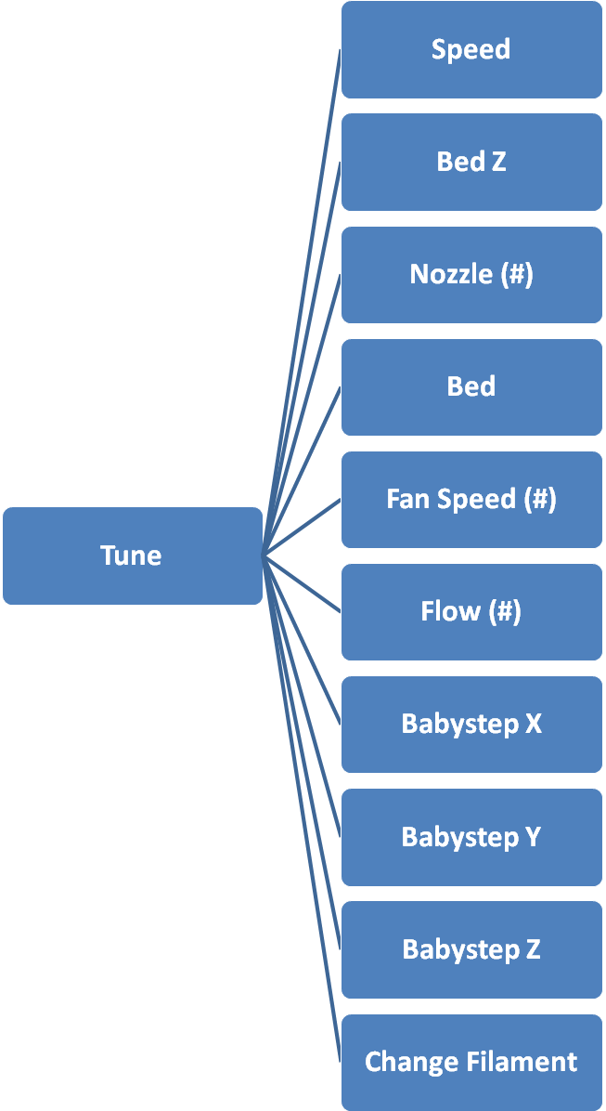

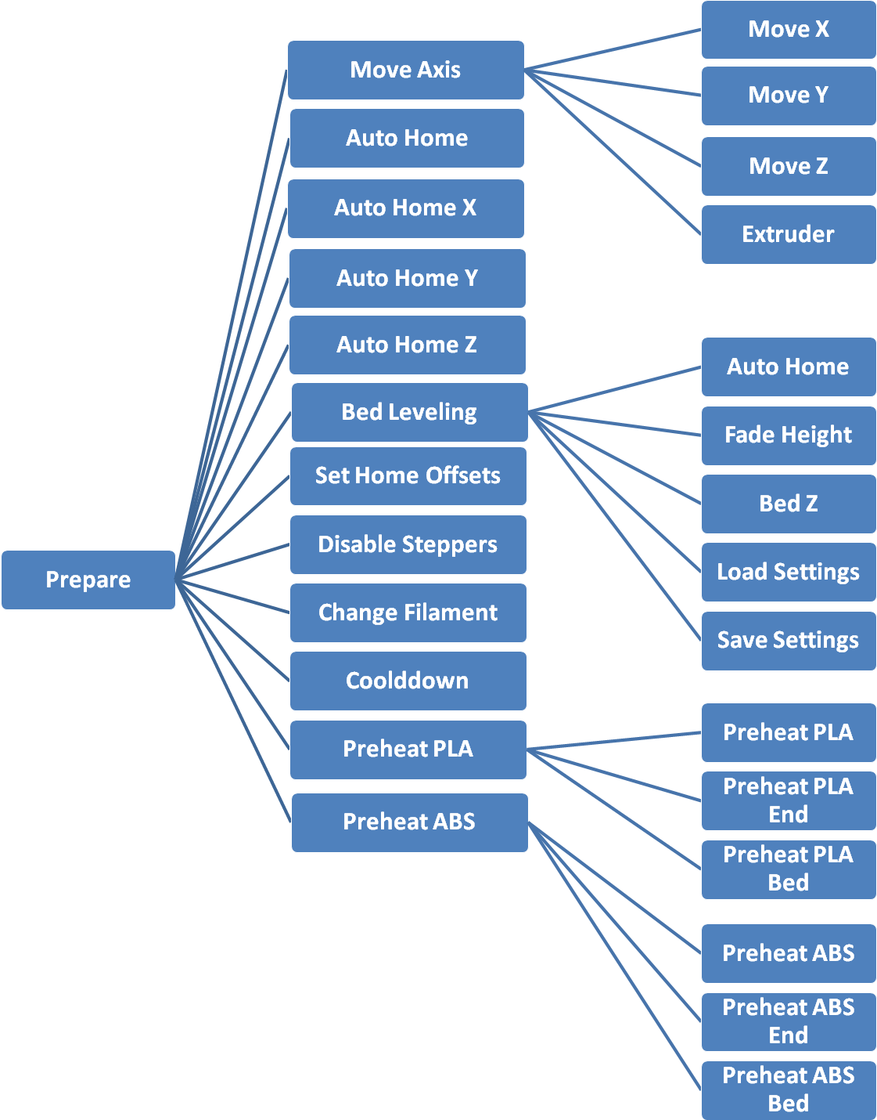
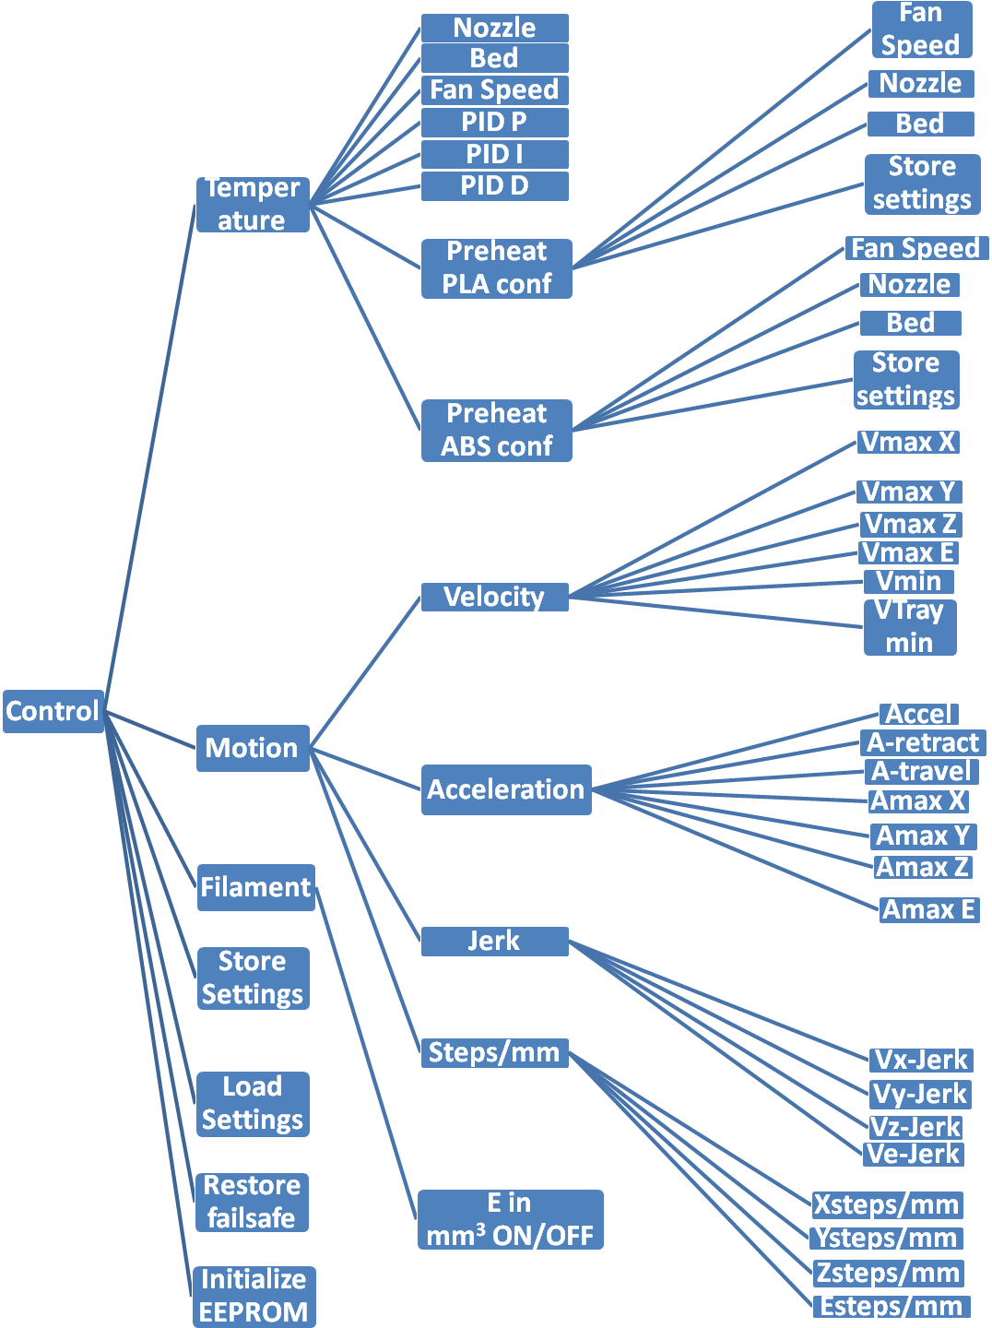
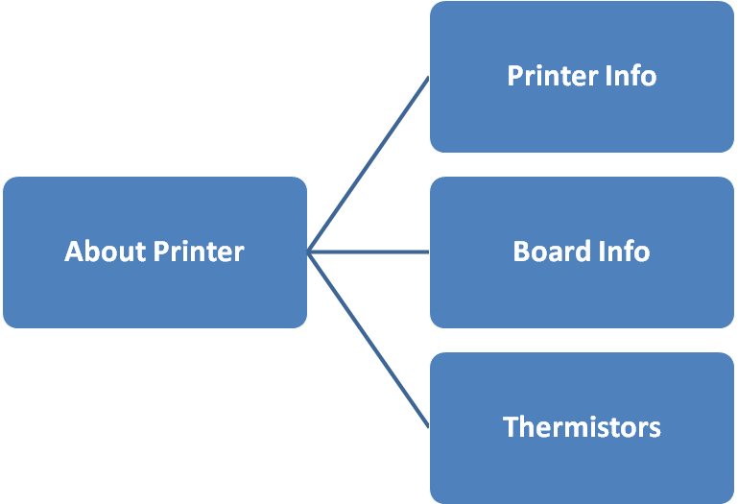

Tune
The Tune menu is only available during active printing. Most items in this menu are editable values.
Item | Description
« Main
Speed: -–- | Set the feedrate
Bed Z: -.-–- | Manual Bed Leveling Z offset
Nozzle (#): -–- | Nozzle temperature(s)
Bed: -–- | Bed temperature(s)
Fan Speed (#): -–- | Speed of part cooling fan
Flow (#): -–- | Extrusion Rate
Babystep X | Fine-tuning X-axis
Babystep Y | Fine-tuning Y-axis
Babystep Z | Fine-tuning Z-axis
Change Filament » | Change filament during printing

Prepare
The Prepare menu is only available when the machine is not printing.
Item | Description
« Main
Move Axis »
Auto Home | Move all axes to respective home positions
Auto Home X | Auto Home X-axis
Auto Home Y | Auto Home Y-axis
Auto Home Z | Auto Home Z-axis
Bed Leveling » | Guided manual probing
Set Home Offsets | Shift nozzle coordinate
Disable Steppers | Disable all Stepper Motors
Change Filament »
Cooldown | Set both Bed and Extruder temperature to zero.
Preheat PLA » | Preheat bed/nozzle for PLA filament
Preheat ABS » | Preheat bed/nozzle for ABS filament

Move Axis
The move axis sub-menu was reorganized for Marlin 1.1. To use the move commands, first select the axis to move, then select the move distance. Use the controller wheel (or arrow buttons) to adjust the axis position. For larger move sizes, Marlin waits until you stop moving the controller for 1/2 second before it starts the move, giving you an opportunity to catch overshoot.
Item | Description
« Prepare
Move X » | Select X move size, do moves
Move Y » | Select Y move size, do moves
Move Z » | Select Z move size, do moves
Extruder » | Set length of filament to be extruded

Bed Leveling
The Bed Leveling menu groups together commands for calibrating the nozzle-to-bed distance. Different options will appear depending on your setup and the type of leveling you’ve enabled. Level Bed runs the default procedure. For auto bed leveling this will deploy the probe, measure all points, and stop. For manual leveling you’ll be taken through a step-by-step process.
Item | Description
« Prepare
Auto Home | All Stepper Motors to Home Position
Fade Height: -.-– | Unified Bed Leveling only
Bed Z: -.-–- | Manipulate Z-axis
Level bed » | Begin Manual Bed Leveling
Load Settings | Retrieves the stored settings from EEPROM, and overwrites whatever is currently in the printer’s SRAM (working memory).
Save Settings | Save settings to EEPROM

Preheat PLA
Set the fan speed plus bed and/or nozzle temperature to the preset “PLA” settings.
Item | Description
« Main
Preheat PLA | Preheat Extruder, bed
Preheat PLA End | Preheat Extruder only
Preheat PLA Bed | Preheat bed

Preheat ABS
Set the fan speed plus bed and/or nozzle temperature to the preset “ABS” settings.
Item | Description
« Main
Preheat ABS | Preheat Extruder, bed
Preheat ABS End | Preheat Extruder only
Preheat ABS Bed | Preheat bed

Control
The Control sub-menu includes the Temperature, Motion, and Filament sub-menus and Settings/EEPROM commands, plus a few other miscellanous hardware control commands.
Item | Description
« Main
Temperature »
Motion »
Filament »
Store settings | Store settings in EEPROM
Load settings | Retrieves the stored settings from EEPROM, and overwrites whatever is currently in the printer’s SRAM (working memory.
Restore failsafe | Settings to defaults
Initialize EEPROM | Default settings and store to EEPROM

Temperature
Use this sub-menu to set the target temperature for nozzles and the bed, fan speed, PID factors, and material preheat settings.
Item | Description
« Control
Nozzle: -–- | Current Extruder Target Temperature
Bed: -–- | Bed Target Temperature
Fan Speed: -–- | Speed of Part Cooling Fan
Pid P: -–- | P parameter of Extruder PID Settings
Pid I: -–- | I parameter of Extruder PID Settings
Pid D: -–- | D parameter of Extruder PID Settings
Preheat PLA conf » | Set extruder and bed temperature for PLA
Preheat ABS conf » | Set extruder and bed temperature for ABS

Preheat PLA conf
The temperatures and fan speed set here will be used for the “Preheat PLA” menu item.
Item | Description
« Control
Fan Speed: -–- | Target Fan Speed when Preheating PLA
Nozzle: -–- | Target Nozzle Temperature when Preheating PLA
Bed: -–- | Target Bed Temperature when Preheating PLA
Store settings | Store Settings in EEPROM

Preheat ABS conf
The temperatures and fan speed set here will be used for the “Preheat ABS” menu item.
Item | Description
« Control
Fan Speed: -–- | Target Fan Speed when Preheating ABS
Nozzle: -–- | Target Nozzle Temperature when Preheating ABS
Bed: -–- | Target Bed Temperature when Preheating ABS
Store settings | Store Settings in EEPROM

Motion
The motion settings provide control over tunable movement parameters which can be stored to EEPROM.
Item | Description
« Control
Velocity » | Velocity settings
Acceleration » | Acceleration settings
Jerk » | Jerk settings
Steps/mm » | Steps/mm for XYZ axes and extruders

Velocity

Item | Description
« Motion
Vmax X: -–- | Max X Velocity (mm/s)
Vmax Y: -–- | Max Y Velocity (mm/s)
Vmax Z: -–- | Max Z Velocity (mm/s)
Vmax E: -–- | Max E Velocity (mm/s)
Vmin: -–- | Min Feedrate (mm/s)
VTrav min: -–- | Min Travel Velocity (mm/s)

Acceleration
Item | Description
« Motion
Accel: -–- | Nominal Acceleration
A-retract: -–- | Retract Acceleration (mm/s²)
A-travel: -–- | Travel Acceleration (mm/s²)
Amax X: -–- | Max X Acceleration (mm/s²)
Amax Y: -–- | Max Y Acceleration (mm/s²)
Amax Z: -–- | Max Z Acceleration (mm/s²)
Amax E: -–- | Max E Acceleration (mm/s²)

Jerk
Item | Description
« Motion
Vx-Jerk: -–- | Max X Jerk
Vy-Jerk: -–- | Max Y Jerk
Vz-Jerk: -–- | Max Z Jerk
Ve-Jerk: -–- | Max E Jerk

Steps/mm
Item | Description
« Motion
Xsteps/mm: -–- | X steps-per-mm
Ysteps/mm: -–- | Y steps-per-mm
Zsteps/mm: -–- | Z steps-per-mm
Esteps/mm: -–- | E steps-per-mm

Filament
Item | Description
« Control
E in mm³ ON/OFF | Volumetric Units

About Printer
Item | Description
« Main
Printer Info » | Printer Info
Board Info » | Printer Board Info
Thermistors » | Bed and Extruder Thermistor Info

FIRST USE

When you turn on the Trendonix ThreeD for the first time, the display shows “TRENDONIX”.
For the first time use, perform Auto Home(to Prepare > Auto Home), level the bed(Prepare > Bed Leveling > Level Bed), load the filament (LOADING AND CHANGING FILAMENT) and then select the files from the SD Card to print.

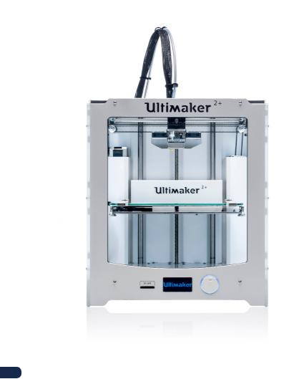

BED LEVELING

For printing it is very important that the first layer is nicely squished into the glass plate and sticks well. If the distance between the nozzle and build plate is too big, your print will not stick properly to the glass plate. On the other hand, if the nozzle is too close to the build plate, it can prevent the filament from extruding from the nozzle. To get the correct distance between the build plate and the nozzle, you need to level the build plate. You must do that before using the Trendonix ThreeD for the first time and then periodically.

Always re-level the build plate when you notice that the plastic is not equally placed on the glass plate. After transportation of your Trendonix ThreeD, it is also advised to re-level the build plate to ensure your 3D prints stick well to the build plate.

To level the build plate:

- Go to Prepare > Bed Levelling > Level Bed. The extruder will move to the Home position. After this, the screen will displaythe following message : “Click to Begin”. Click the knob next to the screen.

- Now the extruder will move to a point on the print bed. There are nine such points in total.

- At each point, rotate the button at the front to adjust the distance of the nozzle from the print bed. Make sure that the nozzle is close to the build plate without touching it. There should be enough distance between the nozzle and the build plate for a piece to paper to slide in and out comfortably from in between the nozzle and the extruder.

- Press “Continue”. The print head moves to the second point

- Repeat the process for the rest of the points.
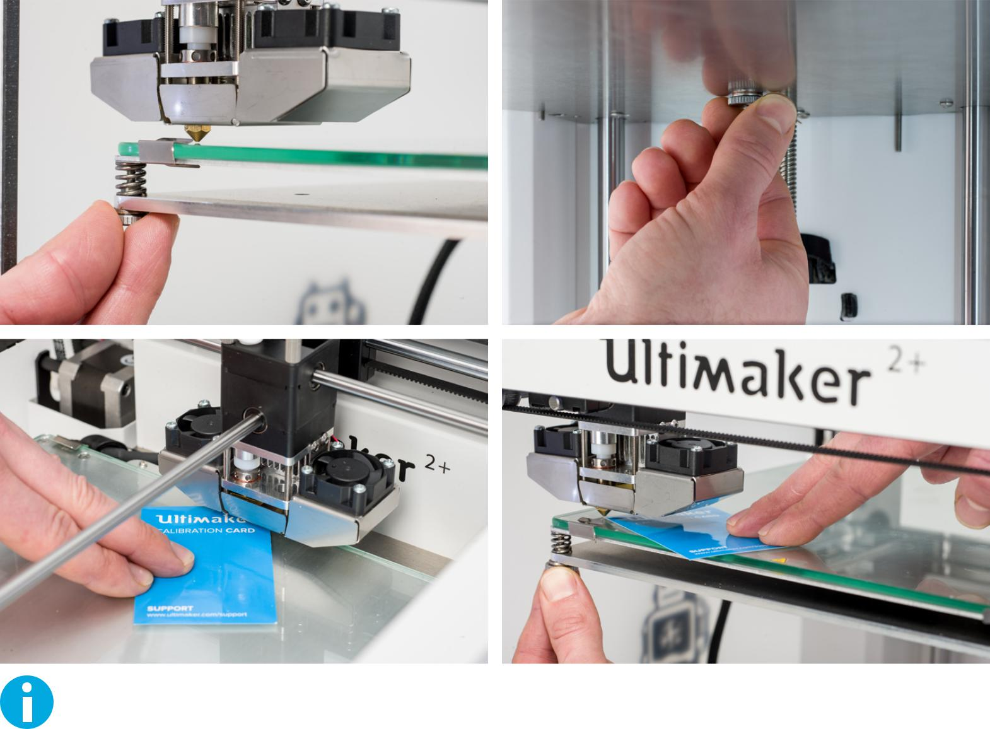

Do not push on the build plate while fine-tuning with the calibration card. This will lead to inaccuracies.

21

LOADING AND CHANGING FILAMENT

LOADING

To load the filament:

- Place the spool with the filament on the spool holder. Make sure to put it with the filament in counter-clockwise direction, so that the filament can enter the feeder from the bottom. Straighten the filament a bit so it can easily enter the feeder.

- Go to Control > Temperature > Nozzle and set the temperature according to the type of your filament. For eg. PLA - 195 ºC, ABS - 230 ºC.(Temperatures may vary according to type and brand of filament.)

- After the nozzle reaches the target temperature, go to Prepare > Change Filament. Follow the steps displayed on the LCD.

- Wait until the filament comes out of the nozzle.
- Once the filament stops extruding, go to Prepare > Cooldown. Then, clean the filament stuck to the tip of the nozzle.
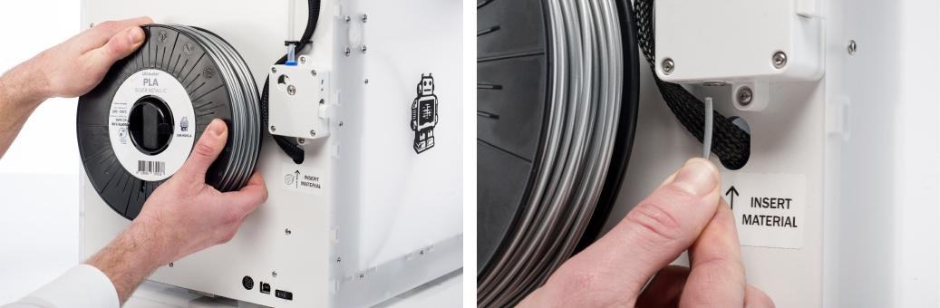

Ensure that you do not touch the nozzle end during this procedure as it will become hot.

Don’t be surprised if the filament that initially comes out of the nozzle is not the color you expect. There is probably some residue from the test print left in the nozzle. Wait until you see the color of the filament that you loaded coming out of the nozzle.

CHANGING

If you want to switch between different (colors of) materials, you first need to unload the filament that is already in the Trendonix ThreeD, after which you can insert the new filament.

To remove the old filament:

- Follow the above steps except that set the value in Prepare > Move Axis > Extruder to a negative value so that the feeder turns in the opposite direction and the filament comes out.

- Load the new filament as described above.

STARTING A PRINT

STARTING A PRINT

When the build plate has been leveled and the filament has been loaded, you can start your (first) print. We’ve placed some print files on the SD card to start with. Simply select one of the files and press the button to start.

After a print file has been chosen, the Trendonix ThreeD will prepare itself by homing the print head and build plate and heating up the build plate and nozzle. Please note that this can take up to 5 minutes or more.

While printing, the display will show the progress of the print and the remaining time for completion. When the print has finished, wait for the build plate to cool down and grab the print from the build plate.

Do not touch the print head/nozzle while it is heating, printing or cooling down. Temperatures can reach up to 260°C.

CURA SOFTWARE

For the Trendonix ThreeD, we recommend the free Cura software to prepare your 3D print files. Cura quickly and accurately converts 3D models into 3D print files within seconds, showing you a preview of the print so you can be sure everything is as you would like it to be.

INSTALLATION

The Cura software can be found at https://goo.gl/Gpvscd . After downloading, open the installer and run the installation wizard to complete the installation.
USING CURA

To convert a 3D model to a print file in Cura:

- Load a 3D model (STL, OBJ, DAE or AMF file) into Cura via the “Load” button.

- Choose your desired settings and wait for Cura to slice the model.

- After Cura has converted the file, save the print file (GCode) via the “Save” button. If the SD card has been inserted, it will directly save the file to the SD card.

- Remove the SD card from your computer - make sure to remove it safely - and insert it into your Trendonix ThreeD to start printing.

UPDATING FIRMWARE

Contact us for updating firmware.

To install the latest firmware on your Trendonix ThreeD:

- Connect the Trendonix ThreeD to your computer with the USB cable.

- Connect the power supply and turn on the Trendonix ThreeD.

- Start Cura and go to Settings > Printers > Manage Printers > Select (make sure the Trendonix ThreeD is selected in the “Machine” menu) and choose “Upgrade Firmware” option. Then Upload Custom Firmware and chose the firmware fille provided by us.

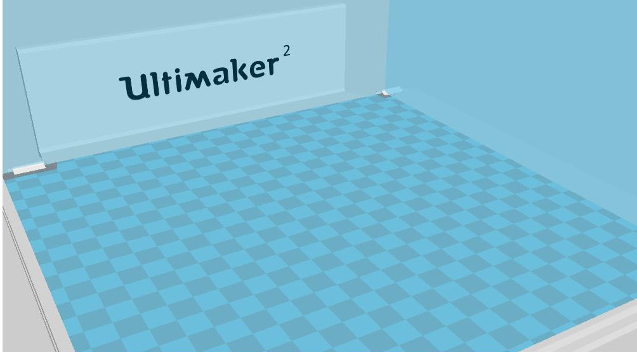

CHANGING NOZZLES

The 0.4 mm nozzle is already installed on the Trendonix ThreeD. An extra nozzle is supplied with the Trendonix ThreeD.

To replace the nozzle:

REMOVING THE CURRENT NOZZLE

- Remove the filament from the Trendonix ThreeD. See “LOADING AND CHANGING FILAMENT” on page __.

- Perform the Atomic Method before removing the currently installed nozzle. This minimizes the amount of leftover plastic that is locking down the nozzle and makes removal easier. It also cleans out that nozzle prior to storage, ensuring that no filament residue remains in the nozzle that may affect future prints. See “ATOMIC METHOD” on page 31.

- Leave the temperature set to the last temperature that was used for pulling out the filament during the Atomic Method. (e.g. 90 degrees Celcius for PLA).

- Use the wrench to unscrew the nozzle from the heater block. To unscrew it, you have to turn it counter-clockwise.

INSTALLING A NEW NOZZLE

- Select the desired nozzle and screw it manually into the heater block until hand-tight. Be careful, the heater block is still warm.

- Use the wrench to tighten the nozzle completely. Turn it clockwise and don’t use too much force (if you tighten it too much, it can break).
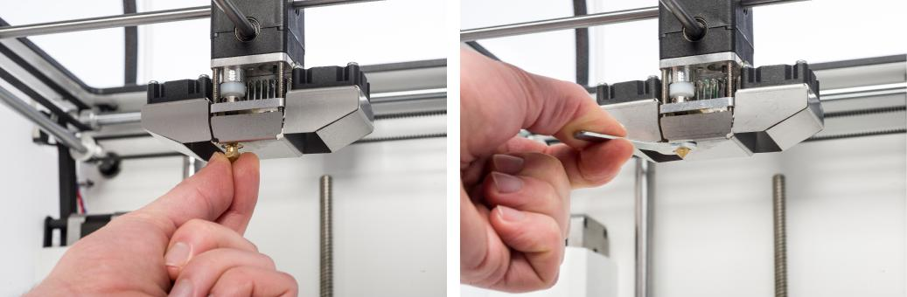

SETTING UP IN CURA

Before being able to print with the newly installed nozzle, the setting in Cura needs to be changed. Enter the size of your installed nozzle, in millimeter, in the “Nozzle size” field.

5
MAINTENANCE

To ensure the smooth functioning of your TRENDONIX ThreeD, it is necessary to maintain it correctly.

Read the maintenance tips detailed in this chapter carefully in order to achieve the best results with your TRENDONIX ThreeD.

THE FEEDER

Using the feeder in the right way and keeping it clean is important for a good extrusion. These are tips to maintain the feeder.

FEEDER TENSION

In order to guide the filament properly through the feeder into the print head, it is important that the tension on the feeder is set correctly. If the tension is too high, it means that the knurled wheel of the feeder will dig into the filament, through which it flattens or gets stuck. This is called grinding.

Do not set the tension of the feeder too high, if you want to prevent grinding of the filament,
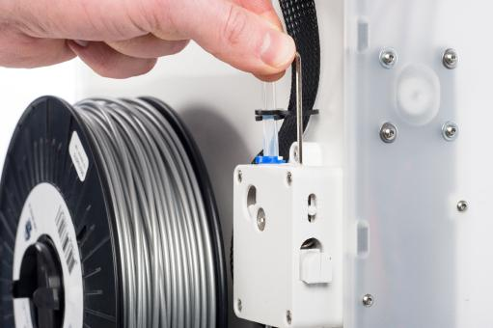

ATOMIC METHOD

After longer use of your Trendonix ThreeD, you might notice that it cannot extrude enough plastic anymore. This so called under extrusion is usually shown by very thin or missing layers in a print. In most cases, it is caused by some dirt or carbonized material in the nozzle or another hot end part through which a (partial) blockage is created. When under extrusion appears, it is recommended to use the Atomic Method in order to clean the nozzle and other hot end parts. Below, the steps of this method are described.

It is also advised to use the Atomic Method when switching from a material that needs a higher printing temperature to one that uses a lower printing temperature in order to make sure any residue from the previous filament is removed.

REMOVING THE FILAMENT
- Follow the instructions for “LOADING AND CHANGING FILAMENT” at Page __ .

HEATING UP AND PREPARING

- Go to Control > Temperature > Nozzle and set the temperature to 260 degrees.

- Cut off approximately 20 cm of filament with a straight cut and try to straighten the filament as much as possible.

- When the temperature is reached, insert the straightened piece of filament manually all the way down to the nozzle.

- Push it slightly until either the new filament comes out of the nozzle or until the filament cannot be pushed any further.
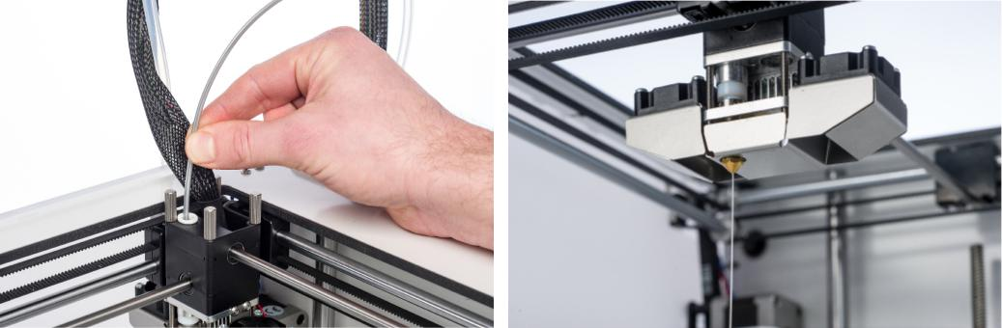

REMOVING THE NEW FILAMENT

- Lower the temperature to 90 degrees (for PLA) or 110 degrees (for ABS).
- To remove the filament follow the steps uder CHANGING in LOADING AND CHANGING FILAMENT” at Page __ .

- Pull the filament out with a quick, firm pull, once the temperature has been reached.

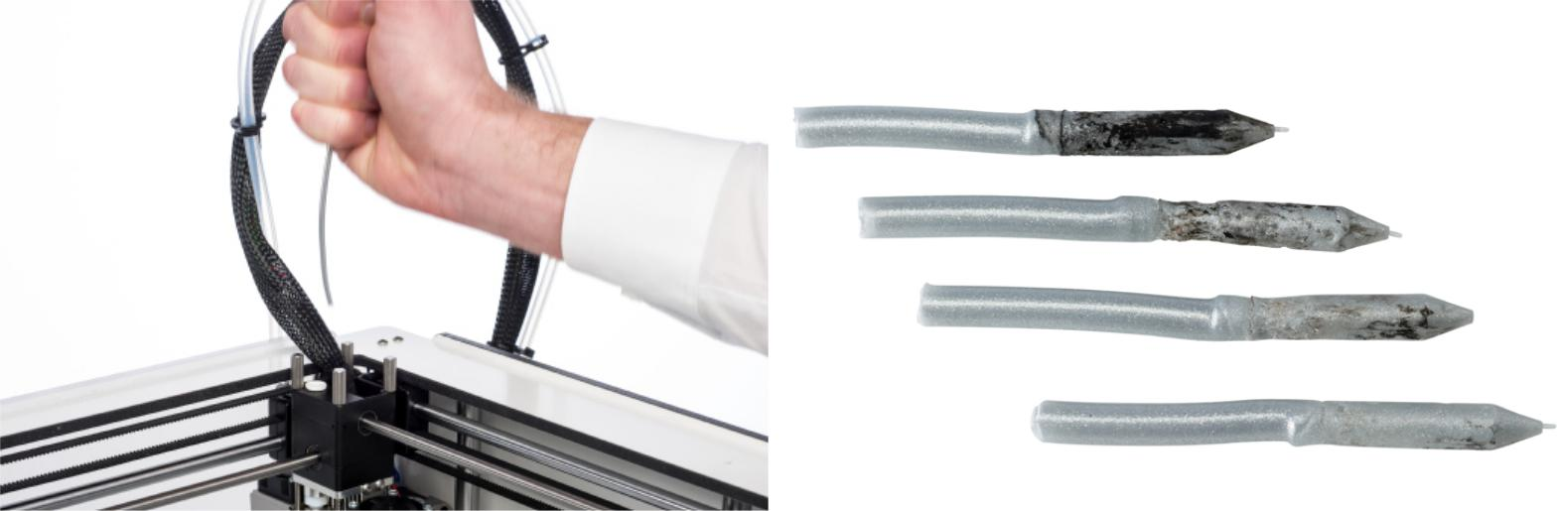

6
HELP AND SUPPORT

The following pages provide Troubleshooting tips for any issues that you might run into.

Read the information provided carefully in order to resolve any issues you might have.

TROUBLESHOOTING

This chapter describes the most common issues and how to fix them. The next page gives an overview of possible error messages on the Trendonix ThreeD. For more instructions, visit our website: http://www.threed.co.in.

EXTRUSION PROBLEMS

Extrusion problems can have several reasons. The nozzle could be blocked, so no material can come out. It could also mean that the Trendonix ThreeD does not extrude enough plastic, leading to very thin or missing layers in a print. This is called “under extrusion”.

In most cases, extrusion problems are caused by some dirt or carbonized material in the nozzle (or another hot end part) through which a (partial) blockage is created. In order to solve this you can:

- Check if the filament has not grinded in the feeder. If it did, remove it from the machine first.

- Try manually to extrude some material. You can put some extra force on it by manually pushing the material at the feeder while doing this.

- Use the Atomic Method to remove any dirt or carbonized material from the hot end.

CANNOT CONNECT TO CURA

If Cura does not recognize your Trendonix ThreeD when you want to upload firmware, there is a problem with the connection due to software or hardware failure. In order to solve this you can:

- Make sure everything is connected properly (power supply and USB cable) and that the Trendonix ThreeD is turned on when uploading firmware. You can also try another USB cable.

- Check if the latest version of Cura is installed on your computer.

- Try connecting to a different computer, preferably with a different operating system.

PRINT NOT STICKING TO BUILD PLATE

When prints do not stick to the build plate, a few things could be wrong. It could either mean that the first layer does not stick well enough or that the prints gets loose due to “warping” of the plastic. Warping basically happens because of the properties of the plastic. Plastics have the tendency to shrink when cooling down fast (some plastics more than others), which could eventually lead to your print curling up (at the corners). You will especially notice this behavior when printing ABS, which has a relatively big shrinkage.

In order to decrease the amount of warping and have a good first layer you can:

- Check if the heated bed is set to the correct temperature (60 °C for PLA and 90 °C for ABS).

- Make sure that the build plate is properly leveled.

- Clean the glass plate completely.

- Apply a thin layer of glue to the glass plate.

- Use the “Brim” feature in Cura to prevent warping. “Brim” will place a single layer thick flat area around your object, thus creating a bigger adhesion surface.

LCD DISPLAY NOT WORKING

The LCD is crucial for controlling the printer. In case the LCD is not functioning properly :
- Check if the wires of the LCD are connected properly.
- Check the corresponding connections on the main circuit board.
- Switch off the mains switch and then switch it back on.
MOTOR NOT WORKING
- Stop the print.
- Switch off the mains.
- Check if the wires of the motors are connected properly.
- Check the corresponding connections on the main circuit board.
- Prepare your STL file again with different parameters to avoid resonance in motors.
- Restart the printer. Home all the axis.
- If the motors still don’t work, then check the motor and its connections carefully.

HEAT BED DOESN’T HEAT UP
- Check if the wires of the heat bed are connected properly.
- Switch off the mains switch.
- Check if the wires of the heat bed are connected properly.
- Check the corresponding connections on the main circuit board.
- Restart printer and try to heat the bed again.
- Use a multimeter at the terminals to check if the heat bed is being supplied the correct amount of voltage.
- Check if the wires of the heat bed thermistor are connected properly.

NOZZLE NOT HEATING UP
- Check if the wires of the nozzle are connected properly.
- Switch off the mains switch.
- Check if the wires of the nozzle are connected properly.
- Check the corresponding connections on the main circuit board.
- Restart printer and try to heat the nozzle again.
- Use a multimeter at the terminals to check if the nozzle is being supplied the correct amount of voltage.
- Check if the wires of the nozzle thermistor are connected properly.

In case you run into any difficulties with your Trendonix ThreeD or need advice on using your Trendonix ThreeD, please visit our website: http://www.threed.co.in.

The website is a great source of information for troubleshooting, solving issues on your own and getting more experienced with 3D printing.

If you ever need personal help resolving an issue with your Trendonix ThreeD, you can also get in touch with us. See our website for contact details.

